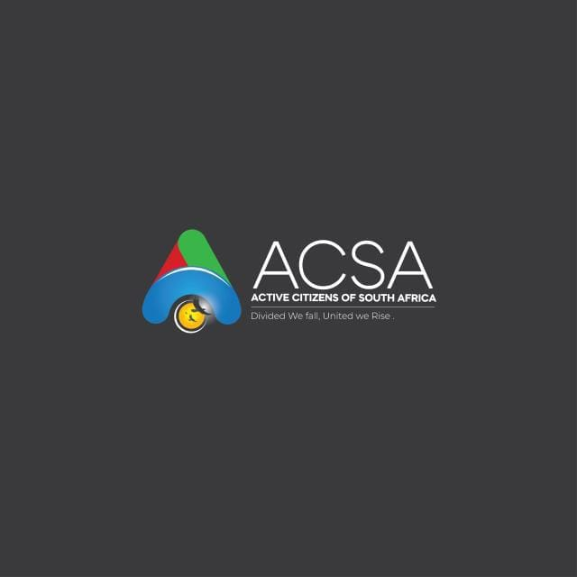
ACSA PROFILE

PREAMBLE
An active citizen is a person who is involved in their community and country by participating in social and political life, engaging in activities like volunteering and advocating for issues that matter. This involvement can range from small, local actions like cleaning up a park or unblocking sewer line to larger efforts such as organizing protests, contacting representatives or participating in public hearings to influence policies.
Ways to be an active Citizen
Civic Engagement:
Participate in elections, community meetings, and other local decision-making process
Advocacy and Expression:
Voice your opinions by contacting your representatives, submitting comments on proposed laws, or participating in peaceful protests and petitins
Community Action:
Volunteer your time to local charities, community projects or non-profit organisations
Local Improvement
Take direct action in your neiborhood, such as cleaning up public spaces, supporting local institutions e.g schools, churches and partnering with local police to address crime
Social Responsibility:
Show kindness and respect to other, support vulnerable members of the community, and report issues like abuse or crime
Environmental Consciousness:
Act in environmentally friendly ways, such as by recycling or participating in greening campaigns.
Support Local Businesses:
Patronize local businesses and organizations to strengthen your community.

BACKGROUND

The Active Citizens of South Africa is not just another organisation vying for power; we are a dedicated movement of concerned and committed citizens, united by a singular purpose: to serve Sedibeng Community with integrity, diligence, and unwavering dedication. ACSA is registered as an NPC with CIPC in 2023. We pledge to you, the residents of Sedibeng Community:
- To Listen: We pledge to always prioritize your voice, your concerns, your aspirations, and your feedback in every decision we make. Our ears will be open, and our hearts will be receptive to the needs of every community member.
- To Act: We pledge to translate our promises into tangible actions and measurable results. No emptier rhetoric; only concrete plans, diligent execution, and visible improvements that uplift our municipality and its people.
- To Serve: We pledge to put the needs of the community above all else, serving with the highest standards of integrity, transparency, and dedication. Our commitment is to the public good, not personal gain.
- To Unite: We pledge to foster a spirit of genuine collaboration, social cohesion, and unity across all communities and demographics within Sedibeng Community. We believe that by working together, we can build a stronger, more resilient, and truly harmonious Sedibeng Community for generations to come.
We extend a heartfelt invitation to every resident of Sedibeng Community to join ACSA in building a future we can all be immensely proud of. Your vote is your most powerful voice, and with ACSA, your voice will not only be heard but will directly lead to real, transformative change.
Why ACSA
- To fight for injustices
- To offer services to the Vaal community
- Solid administration at our municipalities
- Bringing back human dignity
- Eradicate corruption

What is ACSA
- Driving a new dream
- New life
- New possibility
- Change agent
- Economic development

Who is ACSA
- It’s me and you standing up for mediocracy
- Social activism of citizens
- Consumed by flame
- Desire to serve

VISION

A better future and right livelihood for families and individuals in our communities and self-sustainable communities

MISSION

Our mission is to improve the quality of life of the local communities and businesses through sustainable local development initiatives and proper infrastructure backed up service delivery.

CORE VALUES

1. People are at the very center and heart of development; they are the forces behind all we do and every endeavor we undertake.
2. Transparency and accountability drive our actions.
3. Sustainability is built into every intervention we pursue.
4. Integrity
5. Honestly and Trustworthiness

GOAL

Our goal is to uplift the youths and women through capacity building activities to achieve knowledge, skills, networks and motivation that will make them aim to have an improved acceptable living standard and gain human dignity and self-esteem.

OBJECTIVES

- Empower the community through educational programs and internships.
- Our objective is to speed up growth and transformation of the economy and to create decent and sustainable work.
- Initiate programs which will bring about service delivery in many sectors of the vaal:

STAKEHOLDERS

ACSA understand very well that alone it can’t do much. That’s why ACSA is pursuing partnership with Churches, Taxi, Business Chambers, Civic Organisations, FBOs, NGOs, and many other.

